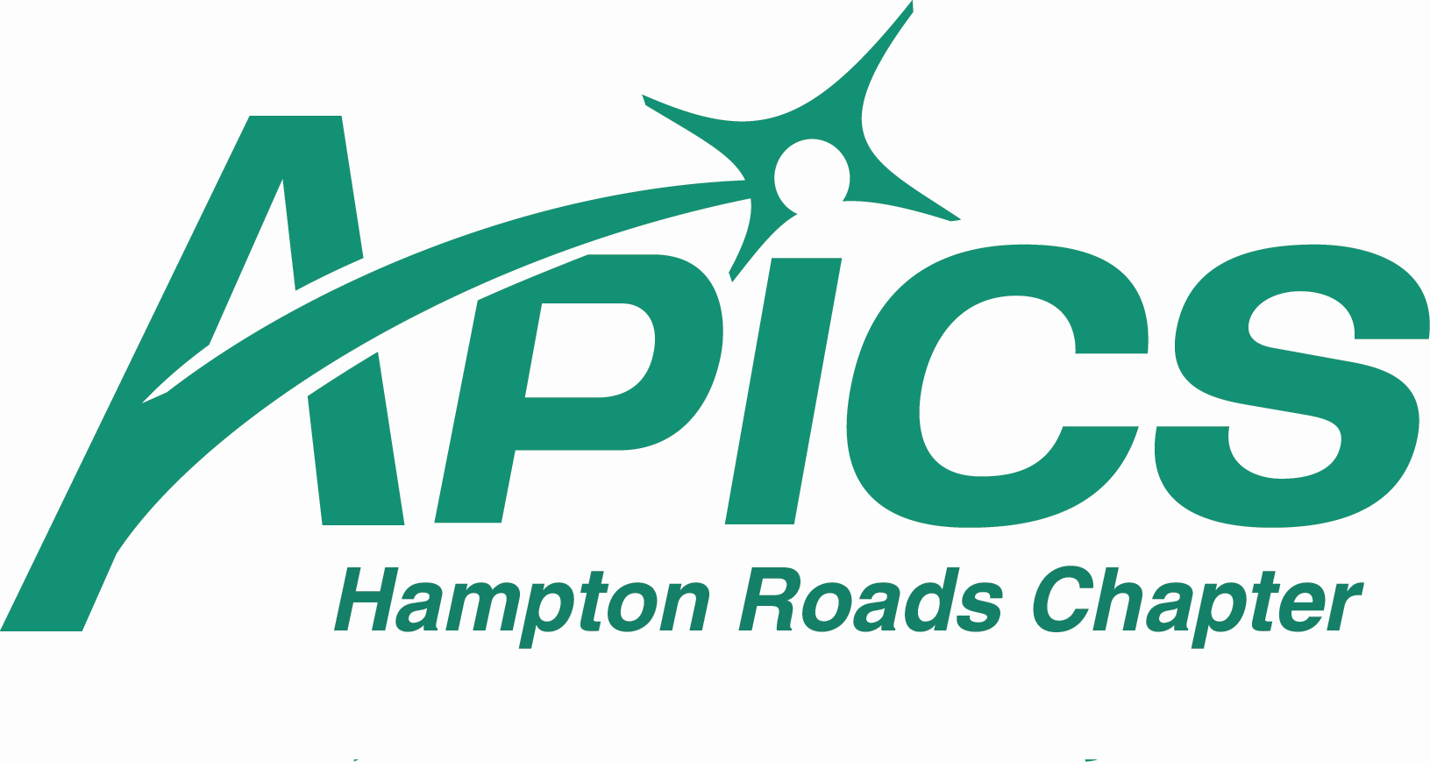

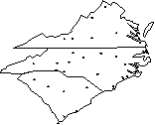
Advancing Productivity, Innovation, and Competitive Success
APICS – Hampton Roads Chapter
Mission Statement
Our Mission is to be the premier provider of operations management education in the Hampton Roads area, providing an open forum for the exchange of ideas and information.

REGION XI

Virginia

North Carolina

South Carolina

UPCOMING EVENTS

Professional Development Meetings*
- Tour of the QVC Distribution Center
  - Tuesday, September 20th at 6pm
  - Suffolk, Virginia

- Leadership vs. Management
  - Dean Ruble, Canon Virginia
  - Tuesday, October 18th at 6pm
  - Peninsula, Location TBA

- Balancing Life & Work
  - Laura Barnes, Averett University
  - Monday, November 14th at 6pm
  - Holiday Inn Select, 1570 N Military Hwy, Norfolk. (757) 213-2231

- December 2005 – Holiday
- January 2006 – speaker/topic TBA, Peninsula Location

- Sarbanes-Oxley
  - Susan West, NGC
  - Tuesday, February 21st at 6pm
  - Holiday Inn Select, 1570 N Military Hwy, Norfolk. (757) 213-2231

- March 2006 – speaker/topic TBA, Peninsula Location

- Material Flow and Sourcing Project - A Siemens case study
  - Harold Robbins CPIM/CIRM, Siemens
  - April 2005
  - Holiday Inn Select, 1570 N Military Hwy, Norfolk. (757) 213-2231

- May 2006 – speaker/topic TBA, Peninsula Location
- Tour of Vitex Packaging
  - June 2006

APICS Conference and Exposition – New Location!
- 2005 APICS International Conference Kansas City Convention Center, Kansas City, Missouri
- October 16-18, 2005
* Please note that tours have no cost and PDMs with speakers are $20/member and $10/student. If an RSVP is received but not attended, the no-show will be invoiced.

New Hampton Roads APICS
website coming in October!

PDMs are worth certification points



Inside this issue:
Pg 1 Hampton Roads Chapter Current Events
Pg 2 Note from the editor
Pg 3 Letter from the Co-Presidents
Pg 4 2005-2006 HR Board of Directors Contact Sheet
Pg 5 APICS 2005 International Conference Update
Pg 6-7 Article: IT'S LEAN IN THE USA, TQM IN CHINA by Michael I. Frichol, CPIM
Pg 8 CPIM 2005-2006 Class Information
Pg 9 Employment Opportunities
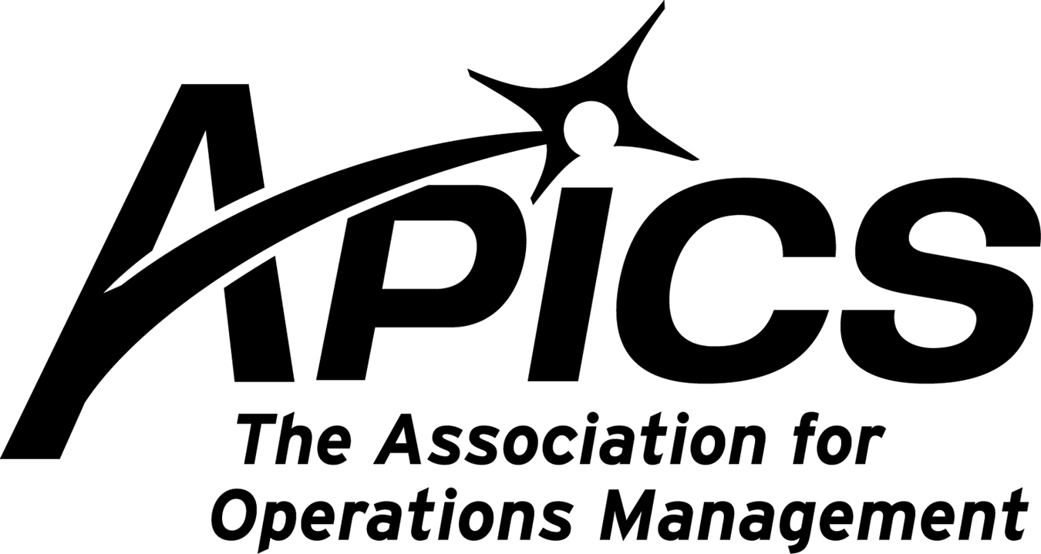
Note from the Editor....

Taking the CPIM test….now easy and convenient in Hampton Roads!

I took my first course review with Harold Robbins a few years back. I had every intention to complete the tests after I finished the review courses. However, when I tried to book my test at the closest location, Richmond, it was booked for months in advance. The only other location was 4 hours away in New Bern, NC. So, like many others, I did not complete my testing.

Fast forward to 2005 and testing in Hampton Roads is now a snap. All I had to do was log onto the APICS Website and follow the links for certification. It was easy to register and pick a time that was convenient for my schedule. I did my tests early Saturday morning to get it them out of the way so I could enjoy the weekend.

On the APICS website you will find information and links to register for exams as below:
Register for a CPIM exam
To register for your next CPIM exam, visit the Promissor Web site or call Promissor Customer Care at 1-800-274-8399 or 610-617-5093. If you have questions, you may wish to consult the FAQs.
CPIM Exam Registration Fees
APICS Members | $110.00 per exam
Nonmembers | $145.00 per exam

And the best part, it is now local. The testing is done at the CompUSA near Military Circle on Virginia Beach Blvd.

So, now I have no excuse to finish my CPIM testing and become certified.

Do you?

Dave Manns
Director of Marketing
APICS - Hampton Roads Chapter
Note from the Editor....

Re-branding APICS… that’s the name of the game in 2005.
I recently attended a marketing and sales summit at the APICS headquarters in Alexandria to learn about the changes that APICS is going through. The APICS leaders and almost 100 chapter volunteers from across North America attended the event. The current President, Tom Krupka, and other board members gave an information packed 2 day seminar on where APICS came from, where it is and where they want to go.
Like many other professional organizations, APICS has been struggling to maintain and grow membership. In 2004 the board began a year long research campaign to aid in redirecting the organization for future growth and success. The result is not just a logo and tag line change, but an overall change in how the APICS product will be branded and sold. The goal is to build on the body of knowledge and hold on to where APICS came from and create renewed excitement by building the brand and growing membership. APICS is to become the voice of the customer again.
I had 3 main takeaways from the summit:
1. The old APICS acronym and tag line were dated and needed to change. The board found the basis for the new APICS right in the APICS dictionary:
def’n ops mgmt
- APICS represents a body of knowledge and expertise that encompasses the entire spectrum of operations management. As the new boilerplate statement illustrates:
APICS The Association for Operations Management is the global leader and premier source of the body of knowledge in operations management, including production, inventory, supply chain, materials management, purchasing, and logistics. Since 1957, individuals and companies have relied on APICS for its superior training, internationally recognized certifications, comprehensive resources, and worldwide network of accomplished industry professionals. To learn more about the APICS community, visit www.apics.org.


Hampton Roads Chapter
Letter from the Co-Presidents
Pamela Adelman, CPIM
Jody Richards, CPIM

Welcome to the first Hampton Roads APICS 2005-2006 newsletter!

We hope you had a safe and fun summer and that you’re looking forward to the cooler temperatures and lower humidity that are on the way. We'd like to introduce you to the new Hampton Roads APICS Board of Directors (BOD) for 2005-2006. Jody Richards and Pam Adelman are co-presidents, Harold Robbins is Treasurer, Dave Manns is Director (Newsletter), Karen Pierce is Director (Membership), Marianne Tully is Director (Company Liaison), John Olson is Director (Education: Southside), and Deborah Waters is Director (Education: Peninsula.) We are all looking forward to seeing and getting to know you in upcoming events.

Speaking of which, our chapter BOD has lined up some dynamic speakers from various backgrounds for your continued educational and professional development and---dare we say it?---enjoyment! Topics will range from balancing your personal life and career life to Sarbanes-Oxley to lean distribution systems. We also have some fun tours book-ending our APICS Professional Development Meeting (PDM) calendar.

We are also pleased to announce that our Education Committee has already set up CPIM Certification classes on the Southside. They are currently working on a schedule for the Peninsula, so keep your eye out for future information.

Currently, our big project is revamping the Hampton Roads APICS website. We are hoping to have the new site up by mid-October. We will be using the new website to keep you posted on upcoming educational events and PDMs. We will also have a new URL and will let you know as soon as the website is ready. We are really looking forward to serving you, our membership, better with this tool.

We would like to hear from you. If you have any suggestions or comments, please feel free to contact any of the board members.

Jody and Pam
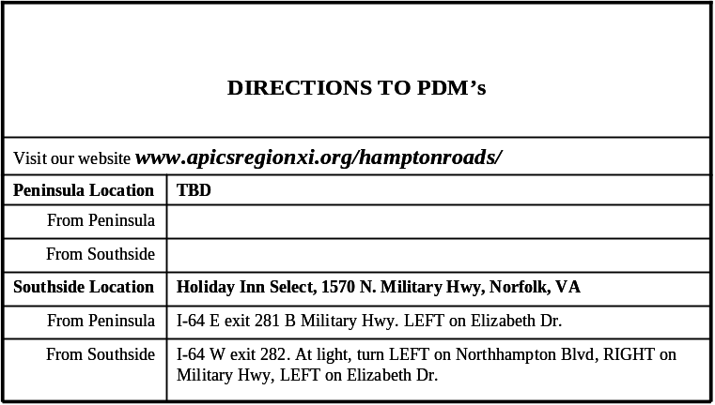
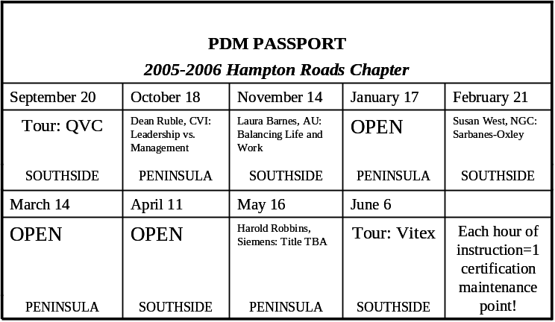
New PDM Passports Coming Soon

2005-2006 Board of Directors Contact Sheet

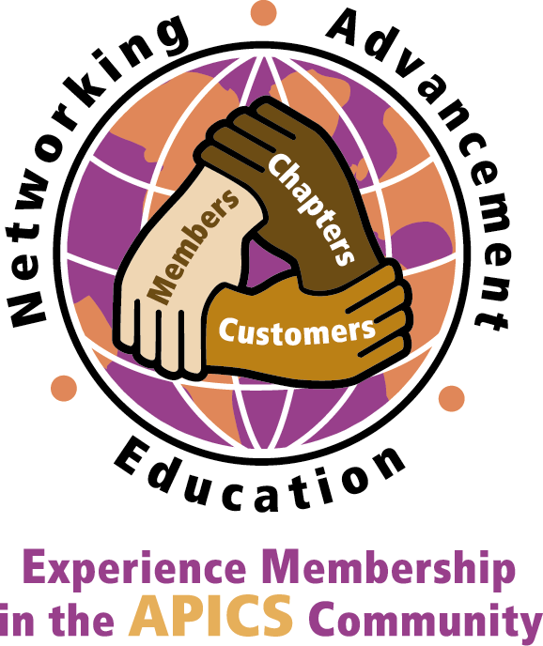
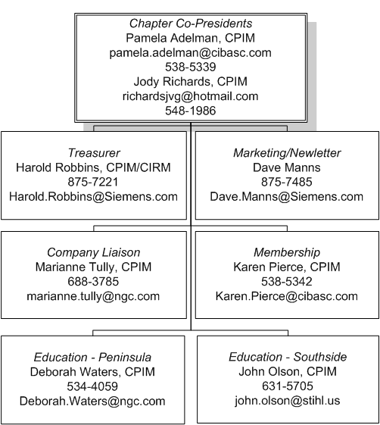

Become a volunteer and earn valuable CPIM maintenance points!

Did you know…


The Hampton Roads Chapter of APICS would like to welcome new members Kris Murphy from Greystone of Virginia, Steven Bloodgood from Iceland Seafood, Lisa Blanton from Tenneco Automotive and Randy Spillers from Hermes Abrasives .

36% of the Hampton Roads chapter members have their CPIM, 4% have CIRM. Membership represents over 45 companies. 65% live on the Southside, 30% on the peninsula and 5% outside the area.

Remember to maintain your hard-earned CPIM or CFPIM designations!

To find out more about the Certification Maintenance Program visit http://www.apics.org/Certification/faq.htm
To find out more about the Certification Maintenance Amnesty Program visit http://www.apics.org/Certification/Maintenance/AmnestyFAQs.htm

International APICS Conference Update, September 9, 2005
The APICS 2005 International Conference and Exposition has been relocated to Kansas City, Missouri, for the same dates of October 16-18. As always, APICS is dedicated to bringing you a quality conference—no matter what city it’s in. We continue to be excited about APICS 2005 and hope to see you there.
Registration
Regular registration for APICS 2005 has been extended through September 30, 2005. Conference attendees who have already registered will automatically be registered in our new location. For registered attendees who can not attend at the new location, please send your cancellation in writing via e-mail to API051.attendee@expoexchange.com, or by mail to APICS, PO Box 590, Frederick, MD 21705-0590 by September 16, 2005 for a full refund.
Housing
Housing is now open, please contact ITS, the APICS Housing Bureau, at (800) 974-9833 or, outside the United States and Canada (847) 940-2386. The new form will be up Monday, September 12.
Travel
Many airlines are offering changes to existing reservations at no cost. If you have already made your plane reservations to New Orleans, please work with the airline directly or a travel agent if you used one to secure the reservation. The dates of the conference are the same, so you can purchase your tickets for Kansas City anytime.

It is our intention to make the transition as simple as possible for those registered and those who have yet to register for the conference. We understand that you have many questions and we are working diligently to tie up all of the necessary details for this relocation.
We will continue to update the Web site with information as it becomes available.
We appreciate your patience and hope to see you at APICS 2005.

Although New Orleans won’t be able to host APICS 2005, our thoughts and prayers are very much with the victims of Hurricane Katrina. The areas and people affected need our help. APICS will be donating the proceeds from our New Orleans lapel pin to the American Red Cross Hurricane 2005 Relief fund. We urge you to donate to one of the many relief funds providing aid to the stricken areas.
Please note that Housing Information is now available on our website. There is a new form for attendees to download and make their reservations. Please access the following link, http://www.apics.org/NR/rdonlyres/D1EB775E-E3AD-4FB8-A59C-C1C03D084675/0/HotelFormandInfo_web.pdf to obtain a copy of the form.

Feature Article: by Michael I. Frichol. Research source: the MPI Group

IT'S LEAN IN THE USA, TQM IN CHINA
The 2004 Census of Manufacturers by Industry Week and the Manufacturing Performance Institute (MPI) produced interesting statistics. Manufacturers were asked which improvement methodology they use and the results are worth noting for several reasons.
The top improvement methodologies used in the United States are
- Lean manufacturing: 42%
- Total quality management (TQM): 14%
- None: 14%
- Lean and six sigma: 11%
- Five other methodologies combined: 19%
The top improvement methodologies used in China are
- TQM: 65%
- Lean manufacturing: 12%
- Other (not on any mainstream list): 8%
- None: 3%
- Five other methodologies combined: 12%
MPI correlated improvement methodologies with business and manufacturing performance results collected in the survey to determine which methodology produced the best results. However, there is no evidence that any particular improvement methodology produced statistically-significantly better performance than any other. Most methodologies focus on essentially the same areas for improvement: lowering inventory, producing the right part the first time, increasing productivity, eliminating waste, optimizing resources, and so forth. But there was a significant correlation between remaining committed to whatever improvement methodology was chosen and achieving significantly better performance results.
All the methodologies provide a set of practices, techniques, and processes that must be implemented as part of the standard procedures in a manufacturing company. Improvement is not just a project—it’s a continuing journey and commitment to a comprehensive set of proven principles to achieve and sustain world-class performance. So the bottom line for manufacturers is that the improvement methodology they adopt is less important than keeping everyone committed to it for the long haul.
There is a huge difference between China and the United States in the chosen methodologies. Why have 65 percent of Chinese companies adopted TQM as the dominant improvement methodology versus the growing trend toward lean manufacturing in the United States and many other countries? A little (unscientific) research was necessary. TQM was the most prevalent improvement methodology in the United States and many other countries during the 1980s through the mid-1990s. Just-in-Time (JIT) was a forerunner of lean in many countries during the same period.

IT'S LEAN IN THE USA, TQM IN CHINA (cont.)
Lean was an emerging methodology in the early 1990s that caught fire with the publication of "Lean Thinking" by James Womack and Daniel Jones in 1996.
Manufacturers had been using JIT, TQM, Toyota Production System, and other methodologies to a limited degree, but "lean thinking" put it all together in one well-organized and structured methodology. So the switch to lean was on in the United States and many other countries. Concurrent with the impetus toward lean, six sigma gained substantial mindshare for quality management in the late 1990s. There is now an emerging methodology of lean six sigma that incorporates principles of lean manufacturing, six sigma, and TQM.
In Japan during the 1950s, W. Edwards Deming was teaching quality management principles that eventually evolved into TQM. Looking at some of Deming’s 14 points, we see they share many common methods and goals with lean manufacturing:
- Don’t depend on mass inspection; build quality in.
- Don’t award business based on price; minimize total cost; build long-term relationships of loyalty and trust with single suppliers.
- Continually improve the system of production, service, planning, and so forth.
- Drive out fear and build trust so everyone can do a better job.
- Break down barriers between departments; abolish competition and build a win-win system of cooperation.
- Involve the entire organization.
TQM and lean are intertwined in many ways.
The lean versus TQM improvement debate seems to be driven more by evolutionary market forces than manufacturing-related issues. Remember when Japan introduced low-cost products of so-so quality in the 1960s? That was followed by low-cost, high-quality products in the 1970s and 1980s, which has been followed by new, innovative products since the early 1990s.
In China, low cost is a given capability, so quality comes next (current state and reason for widespread TQM adoption) and will be followed by innovation. In the United States and many other western countries, innovation and mass production came first, followed by quality improvement and, more recently, low costs and customer service driven by global competition. Lean is being adopted as the primary methodology to achieve low costs and customer service with continuing quality improvement.
However, one disconcerting finding from the study is that 14 percent (one in seven) of U.S. manufacturers have no improvement methodology in place. Contrast that with China where only 3 percent have no improvement methodology. How do companies think they’re going to compete globally without any improvement methodology? It would be interesting to survey manufacturers that shut down or whose business has shrunk to find out what improvement methodology they used. We probably know the answer.
—Michael I. Frichol, CPIM, president of Ingistics LLC, can be reached at Michael@rethinkmfg.com.
Reprinted with Permission.

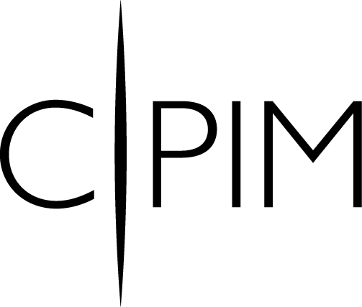

ARE YOU READY?!

2005-2006
CPIM EXAM PREPARATION REVIEW COURSES

Peninsula

January through June 2006
LOCATION: Northrop-Grumman Newport News.
Contact: training@traininghc.com, (757) 285-6464
Dates | Module
Jan 17, 19, 24, 26, 15, 17, 30, Feb 2 | MOD I- BSCM  Basics of Supply Chain Mgt
Feb 14, 16, 21, 23, 28, March 2, 7, 9 | MOD II- MRP  Material Requirements  Planning
Mar 21, 23, 28, 30, April 4, 6,11, 13 | MOD III- DS& P  Detailed Scheduling & Planning
April 25, 27, May 2, 4, 9, 11, 16, 18 | MOD IV- E&CO  Execution & Control of Operations
June 6, 8, 13, 15, 20, 22, 27, 29 | MOD V – SMR  Strategic Management of Resources

South Side

July through November 2006
LOCATION: Stihl, Virginia Beach
Contact: john.olson@stihl.us (757) 631-5705
Tuesdays & Thursdays | Module
Jul 11, 13, 18, 20, 25, 17 Aug 1, 3 | MOD I- BSCM  Basics of Supply Chain Mgt
Aug 15, 17, 22, 24, 29, 31 Sep 5, 7 | MOD II- MPR  Master Planning of Resources
Sep 19, 21, 26, 28 Oct 3, 5, 10, 12 | MOD III- DS& P  Detailed Scheduling & Planning
Oct 24, 26, 31 Nov 2, 7, 9 | MOD IV- ECP  Execution & Control of Operations
Nov 28, 30 Dec 5, 7, 12, 14, 19, 21 | MOD V – SMR  Strategic Management of Resources

Planning Opportunities with 

Since 1926, STIHL has specialized in the development and manufacture of a wide range of high quality, portable power tools including chain saws, trimmers, brushcutters, multi-task products and cut-off machines. STIHL provides a state of the art manufacturing facility located in beautiful Virginia Beach, Virginia. The facility is located on over 70 acres with more than 700,000 feet of manufacturing and warehouse space. Worldwide, STIHL products are sold and serviced in more than 160 countries by some 30,000 dealers.
We are equally as proud to offer our employees the best in benefits.
Invest in your future today!

Explore employment opportunities with STIHL!

PRODUCTION PLANNER B

RESPONSIBILITIES INCLUDE:

- Plan, schedule, prepare and execute production order details.
- Compile and prepare material requirement orders for inventory, issue requisitions for new and special materials. Revise and reschedule orders when necessary.
- Collaborate with inventory control, purchasing, engineering, tool room and other required areas to coordinate schedules.
- Correlate planning and scheduling with the Machine Loading Section to coordinate order release dates for manufacturing to obtain maximum utilization of machines and equipment.
- Monitor and evaluate production statistics, such as downtime, productivity, scrap, etc. and advise on performance standards.
- Evaluate established time standards in relation to actual performance and recommend action as needed.

QUALIFICATIONS:

- Bachelors Degree in a related field or equivalent
- 2-4 years related experience
- Strong mathematical/analytical skills
- Must be able to perform capacity planning and Material Requirements Planning (MRP)
- APICS certification or progress towards a certification a plus
- SAP PP module experience a plus

To apply, please visit StihlUSA.com

APICS Member Contacts: Don Chase – don.chase@stihl.us (757) 306-5650
John Olson – john.olson@stihl.us (757) 631-5705

STIHL is an Equal Opportunity Employer.



